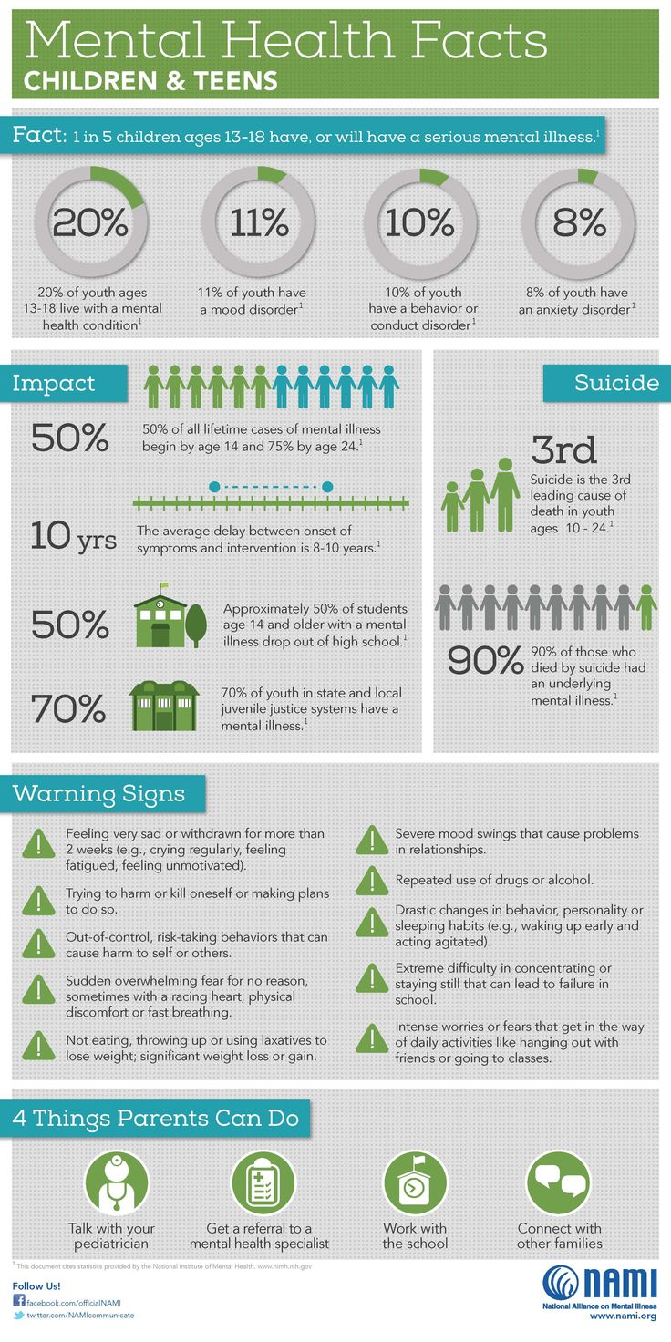
Infographic Project

Accesses and evaluates valid information
Meeting:
- You were able to locate at least 3 valid and reliable sources to gather valuable information on your tech topic.

- You were able to research that information, analyze it and decide what information is most relevant and important for a teen to learn about in your infographic topic.

- Your notes were clear, concise and links to your online sources were included on your note taking sheet.

- A variety of sources were used.

Advocates for personal, family and community health
Meeting:
- Infographic focused on one topic related to the influence of technology on personal health, and included at least 6 supporting facts that are current and relevant.

- Student presented tech challenges but also gave suggestions, solutions or advice for improving balance and technology habits.

- Infographic was designed well and looks professionally done.

- A variety of images were used that supported each of the four facts, and would be visually appealing to anyone reading it.
My Research

1. Facts or Statistics

Supporting Evidence & URL:

2. Facts or Statistics

Supporting Evidence & URL:

3. Facts or Statistics

Supporting Evidence & URL:

4. Facts or Statistics

Supporting Evidence & URL:

5. Facts or Statistics

Supporting Evidence & URL:

6. Facts or Statistics

Supporting Evidence & URL

