Identifying Valid Web Resources

Standard 3.8.1
Analyze the validity of health information, products, and services

Topic:

What’s a typical puberty question that a 6th grader might look up online?

Now enter it into your favorite search engine and find three websites that claim to have the answers.

1. Name of Website: URL:

2. Name of Website: URL:

3. Name of Website: URL:

Which one of the three do you think is the most reliable?

Now back up your decision with five specific reasons why.

1.

2.

3.

4.
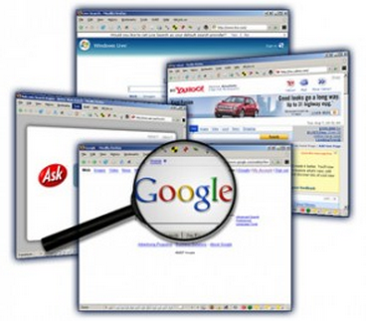
5.

Recommending Valid Web Resources

NHES 8.8.4: Identify ways in which health messages and communication
techniques can be altered for different audiences. Identify ways in which health messages and communication techniques can be altered for different audiences.

Letter of Recommendation:

Now take a second to tell a friend about this website. Please be sure to include the five specific reasons you chose to back up it’s validity, as well as some reasons as to why it would appeal to a typical middle schooler. Also, make sure to share in your letter at least 2 non-website sources/places they could get valid, reliable information about their health. Your letter should have at least five sentences and be written in kid-friendly language.

